*Research protocol articles*

[Empirical research or a knowledge synthesis]

[Authors]

First name Last name, <https://orcid.org/0000-0003-2193-24XX> [ORCID id, optional], Affiliation, Province (or state), Country (E-mail address)

First name Last name, <https://orcid.org/0000-0003-2193-24XX> [ORCID id, optional], Affiliation, Province (or state), Country (E-mail address)

First name Last name*, <https://orcid.org/0000-0003-2193-24XX> [ORCID id, optional], Affiliation, Province (or state), Country (E-mail address)

…,

…,

…,

*Corresponding author

Manuscript word count: … [main text; excluding the authors’ information, abstract, keywords, tables and figures, authors’ contribution, acknowledgements, funding, statement of conflict of interest, ethics certificate number and references]

[Potential reviewers = are not aware of the submission, do not have the same affiliation as the authors, have not collaborated with the authors in the last six years.]

1. First name Last name, E-mail address
2. First name Last name, E-mail address
3. First name Last name, E-mail address

**Title** [In bold. Capitalize the first letter of words with four letters or more, as well as after a colon.]

Abstract word count: …

**Abstract (250 words)** [Numbers should be written in numerals. For example: “The research team developed 4 interview guides based on the theoretical model X”. Keep sentences short.]

**Introduction**: …

**Objective(s)**: ...

[Optional] **Hypotheses**: ...

**Method(s)**: …

**Discussion and Research Spin-offs**: …

**Keywords**:[5] (e.g., mental health; nurses; psychiatry; decision-making; drug use)

**Titre** [French title. In Bold.]

**Résumé (250 mots)** [Écrivez les nombres en chiffres. Par exemple : « L’équipe de recherche a développé 4 guides d’entretien basés sur le modèle théorique X ». Privilégiez les phrases courtes. La structure standard du résumé est précisée ci-dessous.]

**Introduction** : …

**Objectif(s)** : ...

[Facultatif] **Hypothèses** : ...

**Méthode(s)** : …

**Discussion retombées anticipées** : …

**Mots-clés** :[5] (p. ex. : santé mentale; infirmières; psychiatrie; prise de décision; consommation de drogues).

[Text, max. 3000 words. 12-point Times New Roman; 1.5 spaced.]

**Introduction** [Last paragraph of the Introduction must indicate study objective(s).]

…

…

…

[Optional] **Hypotheses**

…

…

…

**Method(s)** [The data collection must be written in the future tense.]

**Subheading1**

…

…

…

**Subheading2**

…

…

…

**Subheading3**

…

…

…

**Discussion and Research Spin-offs**

…

…

…

**Authors’ contribution** [e.g., “GB, LC and GT conducted the interviews. MH wrote the first draft. All authors reviewed and approved the final version.”]

…

**Acknowledgments**

…

**Funding** [If not applicable: “The authors received no funding to conduct the project reported in this article or to draft this article.”]

…

**Statement of conflict of interest** [If not applicable: “The authors declare no conflict of interest.”]

…

**Ethics certificate number** [If not applicable: “An ethics certificate is not required for a synthesis of existing literature, as it does not involve human participants or primary data collection.”]

…

**References** [must be presented using the APA Style’s guiding principles: <https://apastyle.apa.org/style-grammar-guidelines/references/examples>]

…

…

…

**Figures & Tables**

[Figures & tables must follow APA Style’s guiding principles: <https://apastyle.apa.org/style-grammar-guidelines/tables-figures>]

Examples below

**Figure 1**

*PRISMA Diagram from Covidence; January 1, 2013, to July 1, 2024*



**Figure 1**

*Data collection activities*

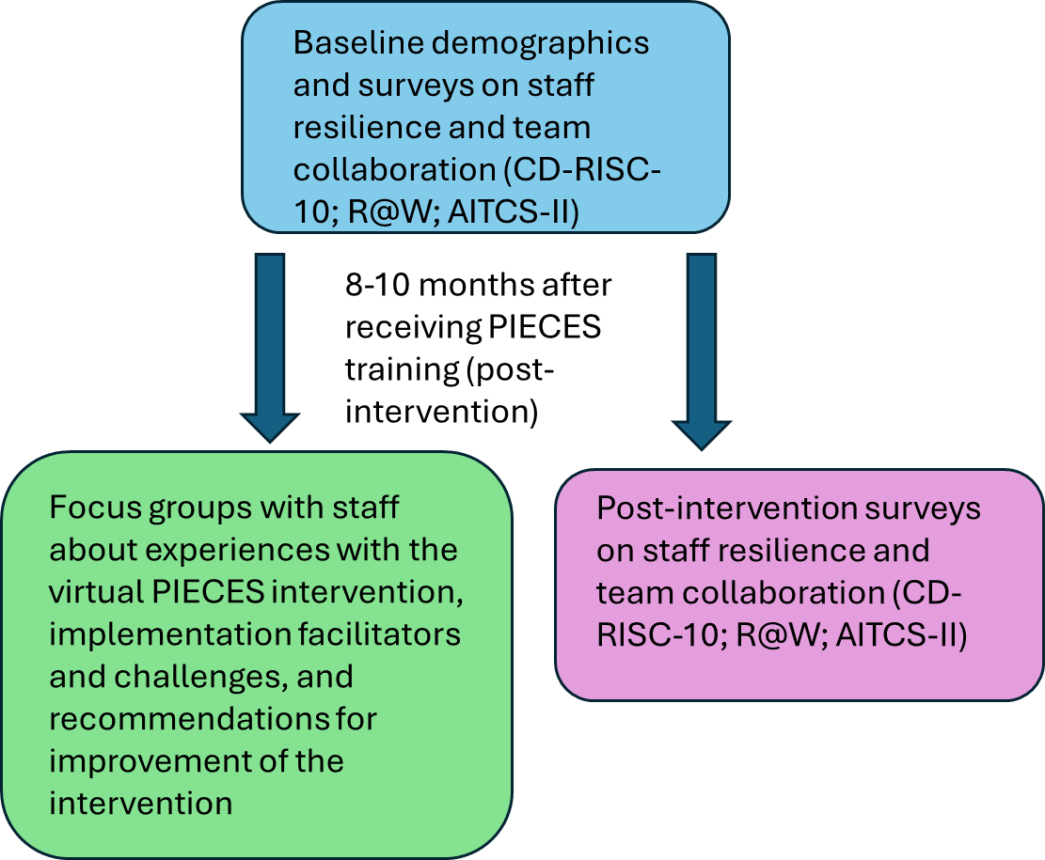

**Tables**

Examples below

**Table 1**

*Example of Focus Group Questions*

|  |
| --- |
| Question |
| 1. What has been your experience in being a part of the implementation of virtual PIECES?    1. What worked well?    2. What could have been done differently or better?    3. What new learnings did you gain in being part of the project? |
| 1. To what extent has the use of the PIECES approach with virtual team collaboration (videoconferencing) changed staff practice?    1. Engagement of family members?  * How does involving family members in the care of residents fit into staff’s daily work experience? * What were the benefits of using virtual technology? * What were the detractions of using virtual technology?   1. Collaboration of team members? * How does the virtual team collaboration aspect of PIECES fit into the staff’s daily work experience? |
| 1. What did you think of the training and mentoring component of the PIECES project? |
| 1. How do you see virtual PIECES being used in the LTC home after the study is completed? |
| 1. How would you describe the level of success of the virtual implementation of the PIECES approach in the LTC home? |
| 1. How complicated is the implementation process of the PIECES approach with virtual care conferences? |
| 1. What do you think will continue to be put in place (e.g., huddles, algorithms, referral processes, PIECES shifts) so that staff can use the PIECES approach? |

**Table 2**

*Means, Standard Deviations, and Bivariate Correlations (Sample 1)*

|  |  |  |  |  |  |  |  |  |  |  |  |  |
| --- | --- | --- | --- | --- | --- | --- | --- | --- | --- | --- | --- | --- |
|  | Means | SD | 1 | 2 | 3 | 4 | 5 | 6 | 7 | 8 | 9 | 10 |
| 1. SBNH-L total | 3.92 | 1.06 | **.96** |  |  |  |  |  |  |  |  |  |
| 2. Age | 41.14 | 11.50 | -.13 | - |  |  |  |  |  |  |  |  |
| 3. Years in current position | 8.35 | 7.25 | -.13 | .57** | - |  |  |  |  |  |  |  |
| 4. Number of subordinates | 59.20 | 142.98 | .18* | -.10 | -.05 | - |  |  |  |  |  |  |
| 5. Team size | 42.14 | 101.87 | .10 | .01 | -.06 | .36** | - |  |  |  |  |  |
| 6. Years as manager | 8.44 | 8.18 | -.05 | .73** | .63** | -.07 | -.02 | - |  |  |  |  |
| 7. Transformational leadership | 4.05 | .58 | .54** | .14 | -.02 | .06 | .08 | .06 | **.82** |  |  |  |
| 8. Servant leadership | 5.67 | .73 | .50** | -.03 | -.11 | .18* | .03 | -.07 | .51** | **.73** |  |  |
| 9. Authentic leadership | 3.07 | .48 | .49** | .09 | -.01 | .14* | .02 | .08 | .65** | .52** | **.87** |  |
| 10. Social desirability | 4.38 | .81 | .13 | .29** | .23** | .08 | -.01 | .19** | .35** | .17** | .25** | **.76** |

*Note.* Values in bold in the diagonal represent Cronbach’s alphas. * *p* < .05. ** *p* < .01.