*Letters to the Editor*

[1) addresses recent content published by the journal, or 2) propose new topics for discussion in the form of well-founded comments that align with the journal’s objectives and scope.]

**Title** [In bold. Capitalize the first letter of words with four letters or more, as well as after a colon.]

**Titre** [French title. In Bold.]

[Max. 5 authors]

First name Last name, <https://orcid.org/0000-0003-2193-24XX> [ORCID id, optional], Affiliation, Province (or state), Country (E-mail address)

First name Last name, <https://orcid.org/0000-0003-2193-24XX> [ORCID id, optional], Affiliation, Province (or state), Country (E-mail address)

First name Last name*, <https://orcid.org/0000-0003-2193-24XX> [ORCID id, optional], Affiliation, Province (or state), Country (E-mail address)

…,

…,

…,

*Corresponding author

Manuscript word count: … [main text; excluding the authors’ information, tables and figures, authors’ contribution, acknowledgements, funding, statement of conflict of interest, ethics certificate number and references]

[Potential reviewers = are not aware of the submission, do not have the same affiliation as the authors, have not collaborated with the authors in the last six years.]

1. First name Last name, E-mail address
2. First name Last name, E-mail address
3. First name Last name, E-mail address

[Text, max. 1500 words. 12-point Times New Roman; 1.5 spaced.]

**Introduction** [Last paragraph of the Introduction must indicate letter objective(s).]

…

…

…

**Other free section**

…

…

…

**Other free section**

…

…

…

**Other free section**

…

…

…

**Conclusion**

…

…

…

**Authors’ contribution** [e.g., “GB, LC and GT conducted the interviews. MH wrote the first draft. All authors reviewed and approved the final version.”]

…

**Acknowledgments**

…

**Funding** [If not applicable: “The authors received no funding to conduct the project reported in this letter to the Editor or to draft this letter.”]

…

**Statement of conflict of interest** [If not applicable: “The authors declare no conflict of interest.”]

…

**Generative Artificial Intelligence (AI) and AI-assisted technologies statement** [If not applicable: “The authors declare that no generative AI tools and AI-assisted technologies were used in the creation of this article.”]

…

**Ethics certificate number** [If not applicable: “An ethics certificate is not required for this letter, as it does not involve human participants or primary data collection.”]

…

**References** [Max. 10 references. They must be presented using the APA Style’s guiding principles: <https://apastyle.apa.org/style-grammar-guidelines/references/examples>]

…

…

…

**Figures & Tables**

[Figures & tables must follow APA Style’s guiding principles: <https://apastyle.apa.org/style-grammar-guidelines/tables-figures>]

Examples below

**Figure 1**

*PRISMA Diagram from Covidence; January 1, 2013, to July 1, 2024*



**Figure 1**

*Data collection activities*

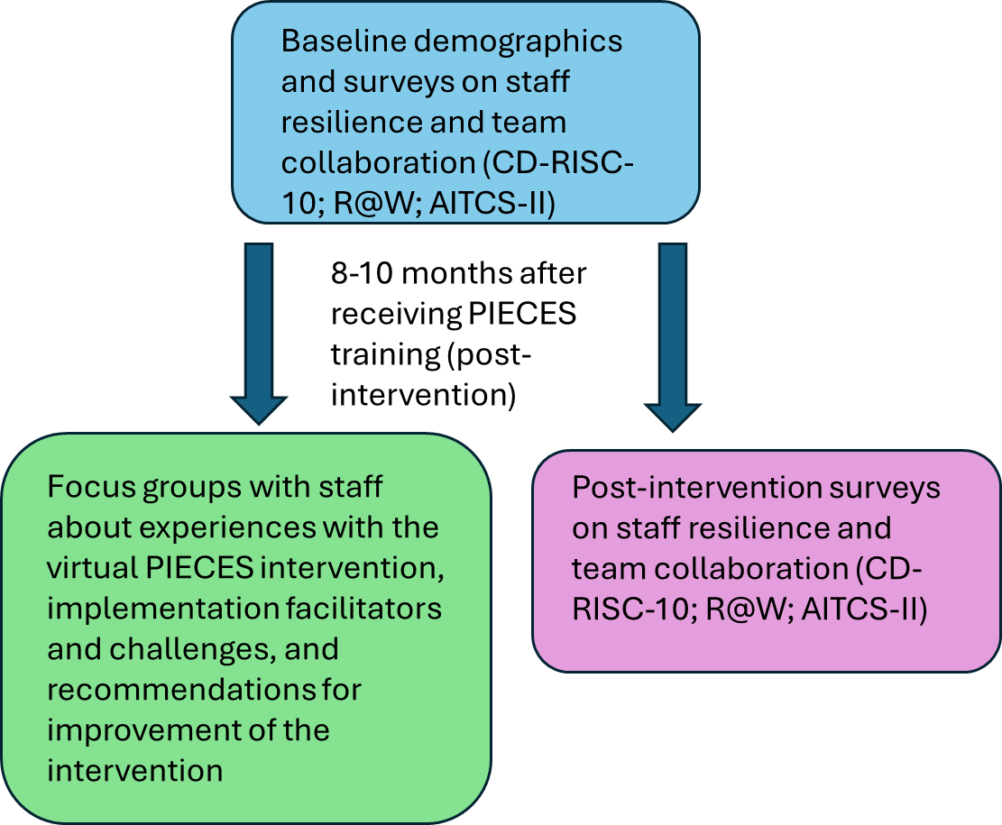

**Tables**

Examples below

**Table 1**

*Example of Focus Group Questions*

|  |
| --- |
| Question |
| 1. What has been your experience in being a part of the implementation of virtual PIECES?    1. What worked well?    2. What could have been done differently or better?    3. What new learnings did you gain in being part of the project? |
| 1. To what extent has the use of the PIECES approach with virtual team collaboration (videoconferencing) changed staff practice?    1. Engagement of family members?  * How does involving family members in the care of residents fit into staff’s daily work experience? * What were the benefits of using virtual technology? * What were the detractions of using virtual technology?   1. Collaboration of team members? * How does the virtual team collaboration aspect of PIECES fit into the staff’s daily work experience? |
| 1. What did you think of the training and mentoring component of the PIECES project? |
| 1. How do you see virtual PIECES being used in the LTC home after the study is completed? |
| 1. How would you describe the level of success of the virtual implementation of the PIECES approach in the LTC home? |
| 1. How complicated is the implementation process of the PIECES approach with virtual care conferences? |
| 1. What do you think will continue to be put in place (e.g., huddles, algorithms, referral processes, PIECES shifts) so that staff can use the PIECES approach? |

**Table 2**

*Means, Standard Deviations, and Bivariate Correlations (Sample 1)*

|  |  |  |  |  |  |  |  |  |  |  |  |  |
| --- | --- | --- | --- | --- | --- | --- | --- | --- | --- | --- | --- | --- |
|  | Means | SD | 1 | 2 | 3 | 4 | 5 | 6 | 7 | 8 | 9 | 10 |
| 1. SBNH-L total | 3.92 | 1.06 | **.96** |  |  |  |  |  |  |  |  |  |
| 2. Age | 41.14 | 11.50 | -.13 | - |  |  |  |  |  |  |  |  |
| 3. Years in current position | 8.35 | 7.25 | -.13 | .57** | - |  |  |  |  |  |  |  |
| 4. Number of subordinates | 59.20 | 142.98 | .18* | -.10 | -.05 | - |  |  |  |  |  |  |
| 5. Team size | 42.14 | 101.87 | .10 | .01 | -.06 | .36** | - |  |  |  |  |  |
| 6. Years as manager | 8.44 | 8.18 | -.05 | .73** | .63** | -.07 | -.02 | - |  |  |  |  |
| 7. Transformational leadership | 4.05 | .58 | .54** | .14 | -.02 | .06 | .08 | .06 | **.82** |  |  |  |
| 8. Servant leadership | 5.67 | .73 | .50** | -.03 | -.11 | .18* | .03 | -.07 | .51** | **.73** |  |  |
| 9. Authentic leadership | 3.07 | .48 | .49** | .09 | -.01 | .14* | .02 | .08 | .65** | .52** | **.87** |  |
| 10. Social desirability | 4.38 | .81 | .13 | .29** | .23** | .08 | -.01 | .19** | .35** | .17** | .25** | **.76** |

*Note.* Values in bold in the diagonal represent Cronbach’s alphas. * *p* < .05. ** *p* < .01.